Name : Siddiqui Umar Farooque
Roll No. : 21CO57
Batch 4
Course: SE

Assignment No. 02

Aim : To perform Version control using Subversion.

Theory :

Version control tracks changes to source code or any other files. A good version control system can tell you what was changed, who changed it, and when it was changed. It allows a software developer to undo any changes to the code, going back to any prior version, release, or date. This can be particularly helpful when a researcher is trying to reproduce results from an earlier paper or report and merely requires documentation of the version number. Version control also provides a mechanism Software Engineering Lab for incorporating changes from multiple developers, an essential feature for large software projects or any projects with geographically remote developers. repository – single location where the current and all prior versions of the files are stored working copy – the local copy of a file from the repository which can be modified and then checked in or “committed” to the repository check-out – the process of creating a working copy from the repository (either the current version or an earlier version) check-in – a check-in or commit occurs when changes made to a working copy are merged into the repository diff – a summary of the differences between a working copy and a file in the repository, often taking the form of the two files side-by-side with differences highlighted conflict – a conflict occurs when two or more developers attempt to make changes to the same file and the system is unable to reconcile the changes update – merges recent changes to the repository into a working copy

The basic steps that one would use to get started with a version control tool are as follows:
1. Creating a Repository
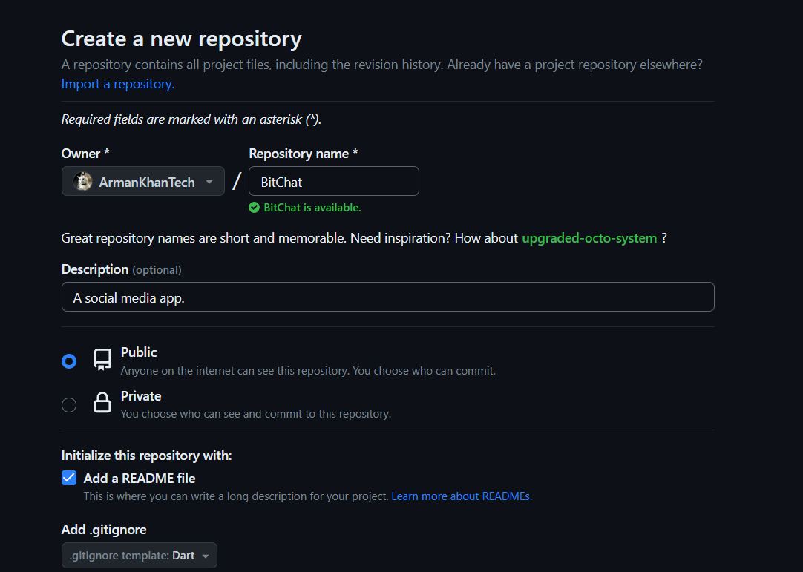

2. Importing a File into the Repository
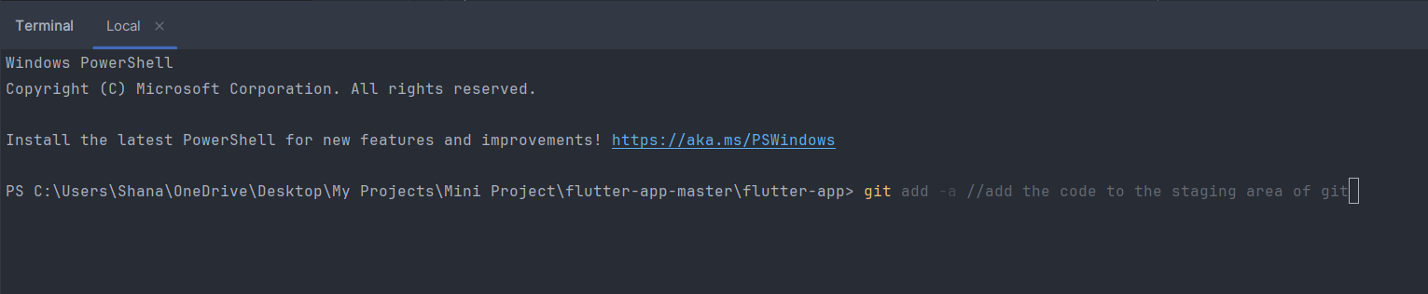

3. Checking the Code out from the Repository 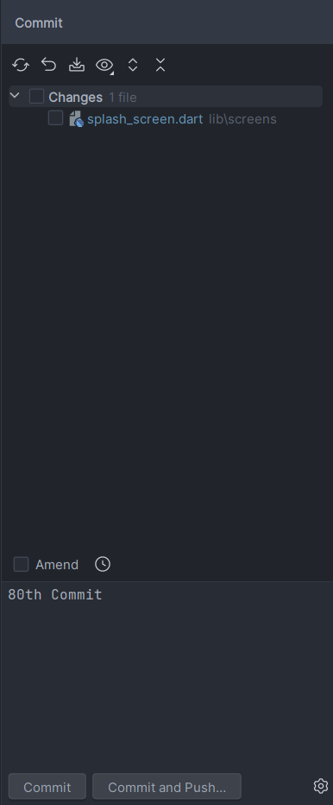

4. Modify the Code and Compare to the Repository Version
